***Chemistry***

**8: Advanced Theories of Covalent Bonding**

**8.1: Valence Bond Theory**

1. Explain how σ and π bonds are similar and how they are different.

Solution

Similarities: Both types of bonds result from overlap of atomic orbitals on adjacent atoms and contain a maximum of two electrons. Differences: σ bonds are stronger and result from end-to-end overlap and all single bonds are σ bonds; π bonds between the same two atoms are weaker because they result from side-by-side overlap, and multiple bonds contain one or more π bonds (in addition to a σ bond).

3. Explain why bonds occur at specific average bond distances instead of the atoms approaching each other infinitely close.

Solution

The specific average bond distance is the distance with the lowest energy. At distances less than the bond distance, the positive charges on the two nuclei repel each other, and the overall energy increases.

5. Use valence bond theory to explain the bonding in O2. Sketch the overlap of the atomic orbitals involved in the bonds in O2.

Solution

Bonding: One σ bond and one π bond. The *s* orbitals are filled and do not overlap. The *p* orbitals overlap along the axis to form a σ bond and side by side to form the π bond.

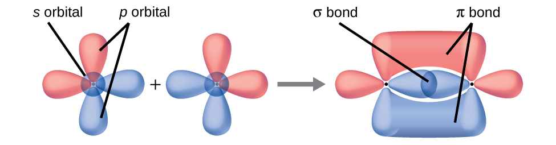

7. A friend tells you N2 has three π bonds due to overlap of the three *p*-orbitals on each N atom. Do you agree?

Solution

No, two of the *p* orbitals (one on each N) will be oriented end to end and will form a σ bond.

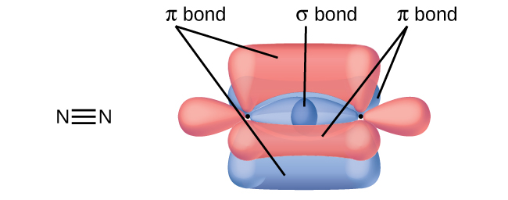

This resource file is copyright 2015, Rice University. All Rights Reserved.